Chapter 15, Solution 26.

- 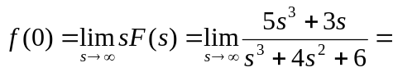5

Two poles are not in the left-half plane.
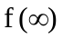

- 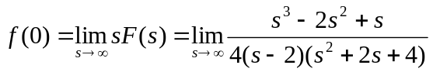
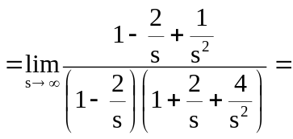0.25

One pole is not in the left-half plane.

